**There are many beautiful places around Nanded to which participants can arrange one day visits. The brief information about some of these locations is given below**

**Gurudwara in Nanded city:**

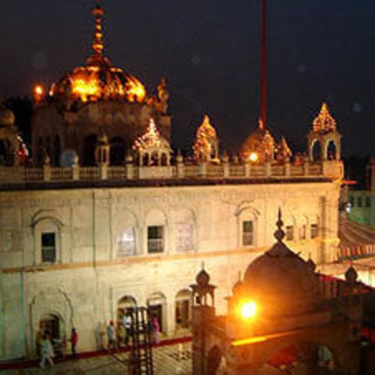

**Located on the banks of the River Godavari, the Hazur Sahib Gurudwara is one of the five thrones ( *takhts*) of temporal authority in Sikhism. The gurudwara within the complex is called "Sach Khand" or the "Realm of Truth". The inner room of the gurudwara is built on top of the place where Guru Gobind Singh (the 10th guru) was cremated in 1708. The gurudwara was built under the supervision of Maharaja Ranjit Singh.   
Recently a laser show has been started at Gobind Bag, near the gurudwara. It briefly depicts the lives of the ten Sikh gurus.**

**Kandhar Fort near Nanded:**

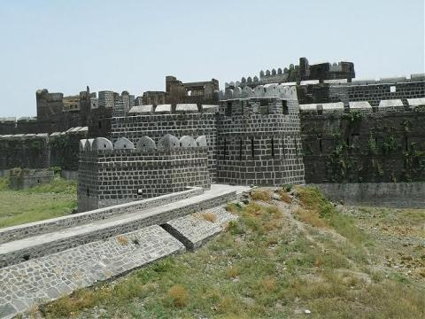

**Kandhar Town, which is 70 KMs away is famous for its fort. Kandhar fort is situated in the heart of Town. Encircling the fort, is a ditch filled with water. It's construction is attributed to the Rashtrakuta King Krishna III of Malkhed who styled himself as Kandharpuradhi Swar. Outside the Kandhar fort at some distance is a hillock on which is situated an old Idgah held in reverence by the muslims. It is of Nizamshahi period with two domes in characteristic Ahmednagar style.**

**Sahastra Kund :**

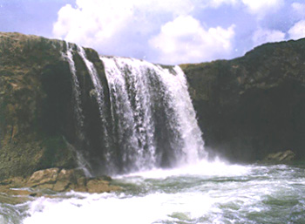

**This waterfall on the Banganga River is an unbelievable site which is 100 KMs away. It flows round the year, as river Banganga makes from four to five places only to meet the Holy Godavari River. The Rock Pattern is equally interesting, as the black rock appears like a metal and as if wet. In reality the wetness is due to the shine it adores. The southwest part is picturesque site.**

### Unkeshwar:

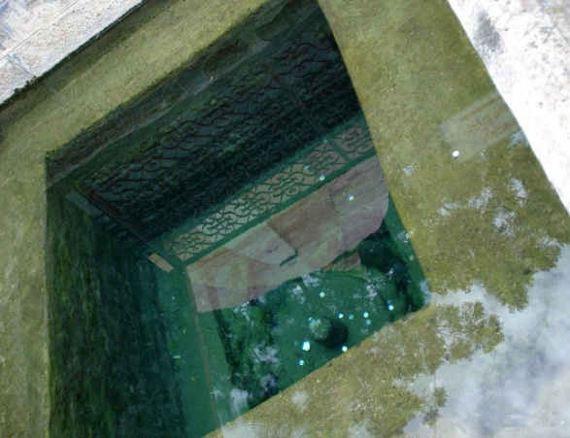

**Unkeshwar which is 165 KMs away is famous for the temple dedicated to God Siva and the hot springs located close by the temple. These springs are said to possess medicinal value and cure skin diseases. The temperature of water in one tank stands at 42.20 C and is found to contain sulphur in water springs. The excess water flows out from the Gomukh. Many bubbles are seen in the tank which indicates sulphur contents as per the experts.**